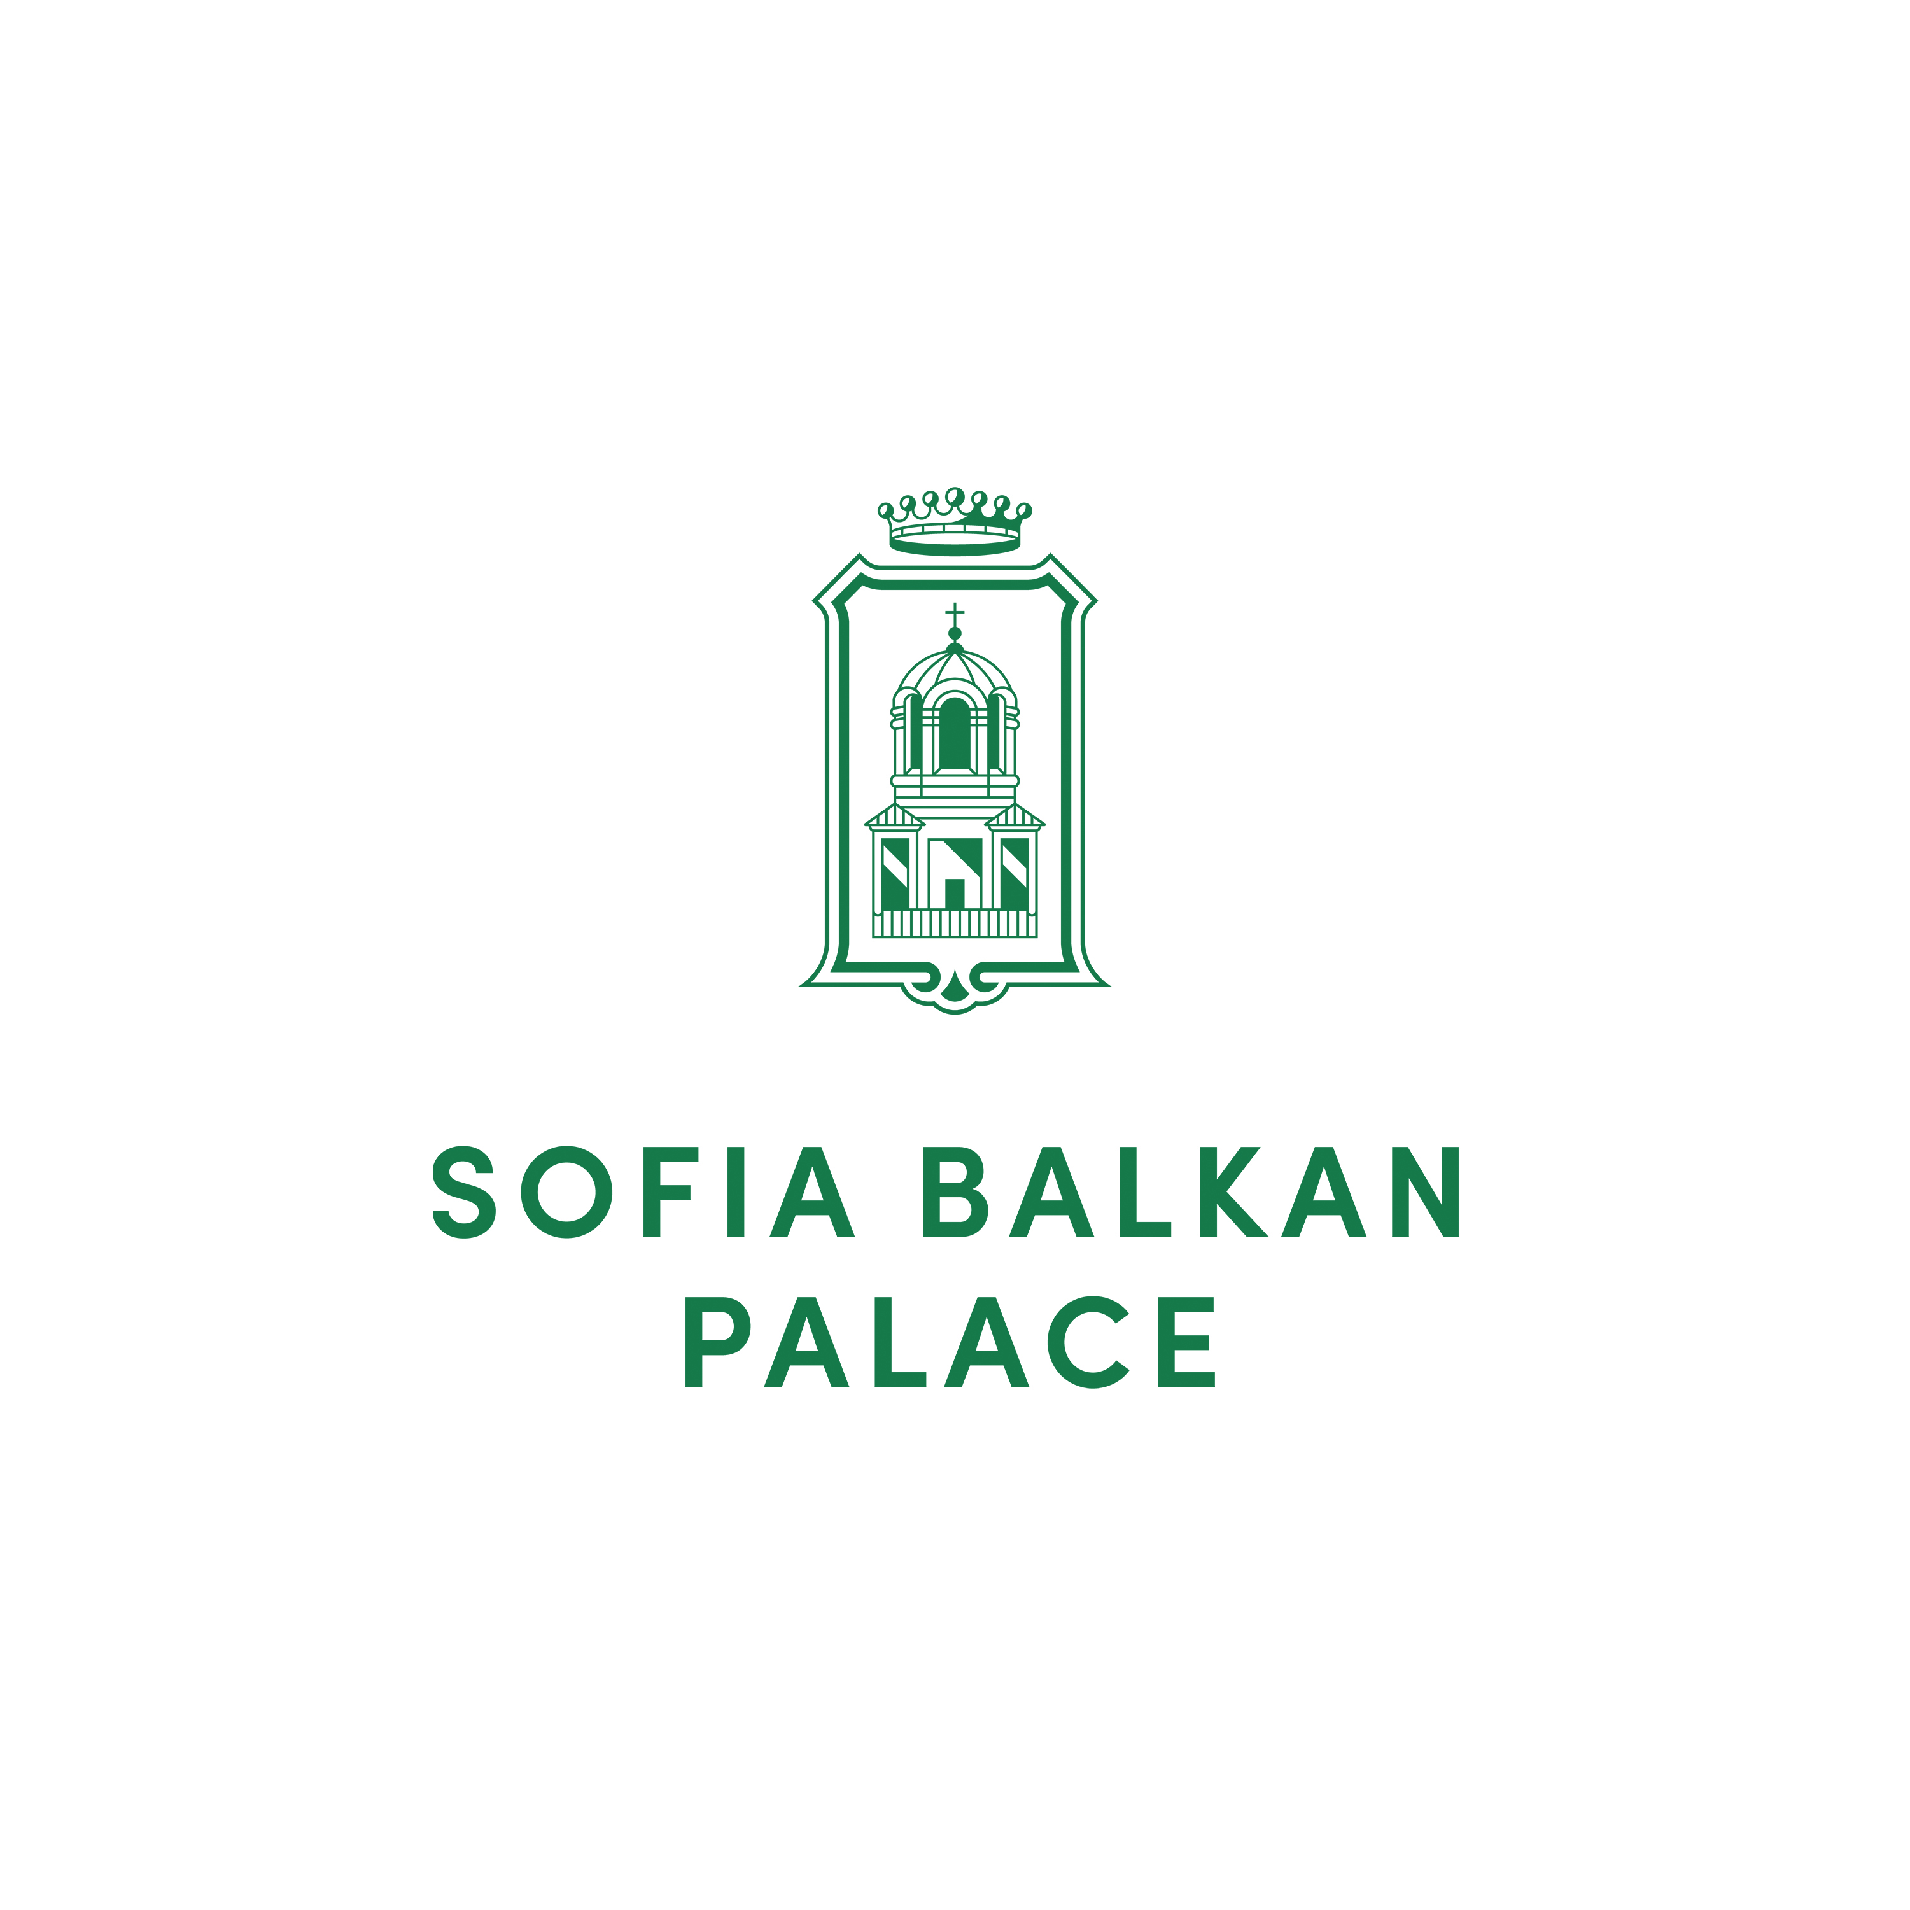

RESERVATION FORM
Real World Crypto 2025
24-29 MARCH 2025

In order to book a room at Sofia Balkan Palace, please complete the details below and e-mail the form to our e-mail address below:

Sofia Balkan Palace
e-mail: evelin.beshkova@sofiabalkan.net; reservation@sofiabalkan.net

Phone: (359) (2) 937 8787
Family name:____________________________First name:_____________________

Company:_____________________________________________________________

Tel:____________________Fax:____________________ E-mail:________________

Arrival date: Departure date:

Cross the room type you require, indicate the total number of rooms and nights required

Deluxe King Single room EUR 140, - Deluxe King Double room EUR 150, -
Deluxe Suite Single room EUR 150, - Deluxe Suite Double room EUR 160, -

Total nights:__________________________ No. of rooms:_________________________

Rates are quoted per room, per night, inclusive of buffet breakfast and 9%V.A.T.
EUR 0.67 Tourist tax per person per night will be charged additionally as Tourist tax.
Once Deluxe King rooms are sold out the next available room category will be confirmed.

Please indicate the method of payment and guarantee reservation with credit card details:

Credit card name:_______________________ Number:________________________

Expiry date:___________________________ Signature:_______________________

Cancellation policy:
- One night's room revenue will be charged for each room cancelled after 24th of February 2025.
- Guestroom Cancellation between 5 to 0 days prior to arrival, no-show or early departure: All cancelled guestrooms will be charged at full amount for the full duration of the agreed stay.

DEADLINE FOR RESERVATIONS IS FEBRUARY 24th 2025
After this date all unsold rooms will be released and all additional reservations will be subject to availability.

